_____________________________________________________________________________________________

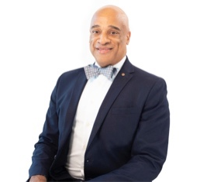
AN IMPORTANT MESSAGE FROM OUR
FOUNDER AND BOARD OF DIRECTORS

As an education organization dedicated to eradicating racism, bias and prejudice, DLA stands for Justice and Equity and will continue to serve as a pivotal resource for sustainable change in our community.

The tragic and senseless killing of George Floyd and so many other African American men and women in our communities speaks squarely to the deep-rooted, systemic racism that exists in America. We must be vigilant in identifying, addressing head-on and eradicating this racism in order to bring about real change. We hear you and we feel your pain, hurt, anger and fear and want to take all of that energy and harness it into a powerful tool of action, where through Education we can begin a series of healing dialogues that ignites change.
_____________________________________________________________________________________________

